**Data Tables in Cucumber**

Data table is a set of input to be provided for a single tag. This tag can be GIVEN, WHEN, or THEN.

https://www.youtube.com/watch?v=zx-y0svMGWk

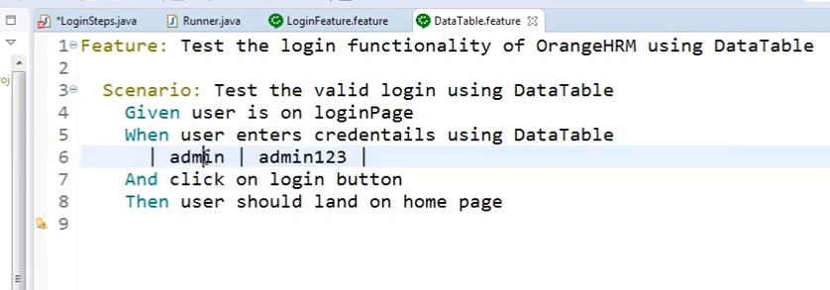

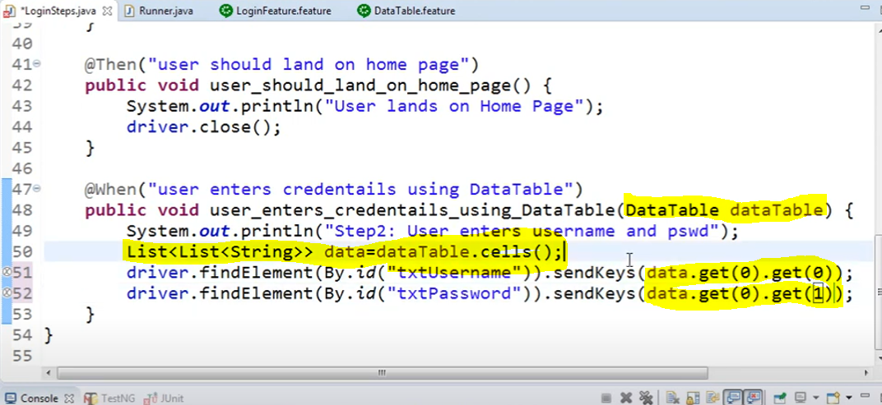

<https://www.youtube.com/watch?v=ltuirHp0u14>

